Student Portal Tips

To login:

- Go to the following website: https://portal.austinisd.org
- Username - uppercase S + student ID#
Password - uppercase first letter of your last name + 6-digit date of birth + lowercase s

For example -
Username - S12345678
Password – F021409s

​
​Bookmark Important Apps:
Once students have logged into their portal, they can bookmark important apps that we will be using throughout the upcoming weeks.
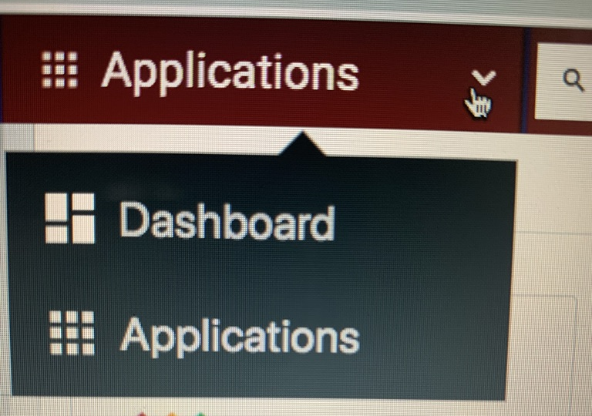
- Go to Applications.

- Click-on the bookmark on the bottom left corner of the app you want to bookmark

- This will place the app on your Dashboard so that you will not have to search for the app every time you need to access it.

Important Apps to Bookmark:

BLEND: This is where students will go to access assignments/work for the week.

HMH Think Central: Fusion Science Book

HMH Ed.: Language Arts Book

Studies Weekly: Social Studies and Science Newspapers

DreamBox: Math Lessons Assigned Here

Other apps that we may use or apps that students can explore on their own:
**Students may bookmark any other apps that they would like to use. The above apps are just those that we will reference in their assignments at some point.**

